| **""** | **HANDS-ON LAB** Measure Density |
| --- | --- |

You will measure the mass and volume of objects in order to calculate their density. You will use formulas as well as the water displacement method to measure the volume of these objects.

A book and a brick are regular-shaped objects whose dimensions can be measured with a meter stick. The volume of irregular-shaped objects, such as a large key, should be measured using water displacement.

## Materials

* graduated cylinder
* ruler (or meter stick)
* scale (or balance)
* water

 

## Procedure

**STEP 1** You will be provided 3 objects for which you will calculate the density. Two of the objects can be any size, but should be rectangular prisms. The other object can be any shape, but must be solid metal and fit in a graduated cylinder. Record your objects in the first column of the table below.

**STEP 2** Predict which objects will be the most and least dense. Explain your reasoning. (5 points)

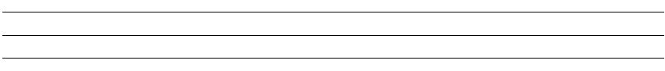

**STEP 3** Measure the mass of each object. Record your data in the table.

**STEP 4** Measure the length, height, and width of the two rectangular prisms. Use these measurements to calculate the volumes of the two objects. Record your data in the table.

**STEP 5** Calculate the density of each rectangular prism. Record your data in the table.

**STEP 6** Use the water displacement method to determine the volume of the metal object. Make sure the object is completely underwater when you record its volume. Record your data in the table. Wipe up any spilled water immediately.

**STEP 7** Calculate the density of the metal object. Record your data in the table. (table = 25 points)

| **Object** | **Volume** | **Mass** | **Density** | **Material** |
| --- | --- | --- | --- | --- |
|  |  |  |  |  |
|  |  |  |  |  |
|  |  |  |  |  |

**STEP 8** Use the density calculations and physical appearance to identify the materials. Use the charts provided by your teacher.

## Analysis (5 points each)

**STEP 9** How are the masses and volumes of the objects related to their densities?

**STEP 10** Which of the objects that you measured was the least dense?

**STEP 11** Why did the least dense object you measured have such a low density?

**STEP 12** What can you conclude about the densities of different materials- do all materials have the same density? Explain.